

Database Systems Lab

Project Report

Supervised by
Miss Sabeen

Database Systems Lab Project
BS Computer Science, Batch 2022F

Employee Management System

Group Members:
Name | Roll Number
Saad Ali | 2022F-BCS-162
Hamza Khan | 2022F-BCS-180
Muhammad Faisal | 2022F-BCS-152
Muhammad Khubaib | 2022F-BCS-191

Supervisor

Project Report: Employee Management System

- Introduction
The Employee Management System (EMS) is a comprehensive solution developed to streamline the management of employee data within an organization. This system is built using C# Windows Forms for the user interface and SQL Server for the database management, ensuring robust and efficient handling of employee-related operations.

- Project Objective
The primary objective of the EMS is to provide a user-friendly interface for managing employee data, including adding, updating, and deleting employee records, managing projects, and handling salaries. The system aims to enhance productivity by automating routine tasks and providing real-time data access to administrators, managers, and employees.

- Features

- User Types
- Admin: Has full access to all features, including adding, updating, and deleting employee records, managing salaries, and overseeing projects.
- Manager: Can view and manage projects assigned to them and oversee the work of their team members.
- Employee: Can view available projects, accept tasks, and update the status of their tickets.

- Login System
- Employees log in using their employee ID and password.
- Admin ID is fixed at 1000, manager IDs range from 1001 to 1099, and employee IDs start from 1100.
- Only active employees can log in; inactive employees receive an error message.

- Dashboard
- Displays total employees, active employees, and inactive employees.
- Shows department information and employee data.
- Includes a pie chart representing the total available tickets of current projects.

- Employee Management
- Admin can add, update, and delete employee records.
- Employee data includes ID, full name, phone number, gender, position, status, password, manager ID, and department ID.
- Positions are predefined and include roles such as Developer, Designer, Consultant, etc.
- Passwords must meet specific security criteria.

- Salary Management
- Admin can update employee salaries.
- Salary data is linked to the employee record and can be viewed and edited through the salary management interface.

- Project Management
- Admin: Can create, update, and delete projects, assigning them to managers.
- Manager: Can view project details, track progress, and oversee team member contributions.
- Employee: Can view available projects, accept tasks, and update ticket statuses.

- Project Details
- Projects have IDs, names, number of tickets, manager IDs, and statuses (available or complete).
- Employees can accept tickets and update their status to complete when finished.
- Managers and employees can track project and ticket statuses through detailed overviews.

- Technologies Used
- C# Windows Forms: Provides a user-friendly and interactive graphical user interface.
- SQL Server: Manages the database, ensuring data integrity and security.
- Visual Studio: Integrated development environment used for building the application.

- Conclusion
The Employee Management System is a robust application designed to facilitate efficient management of employee and project data. By leveraging C# Windows Forms and SQL Server, the system offers a secure and user-friendly interface for administrators, managers, and employees, enhancing overall productivity and organizational management. This project exemplifies the application of modern software development practices in solving real-world business challenges.

ER-Diagram
Active
Inactive
d
Login
dddd
EMS
Employee

Department

Admin
Manager

CRUD

CRUD
Manages

Holds
Project

Completes

Ticket

Schema
Employee { EMP_ID, emp_name, contact_num, gender, position, salary, insert_date, update_date, delete_date, status, pass, MGR_ID, DEPT_ID (foreign key references Department.DEPT_ID) }

Department{ DEPT_ID, dept_name }

Ticket { TICKET_ID, PROJ_ID (foreign key references Project.PROJ_ID), EMP_ID (foreign key references Employee.EMP_ID), ticket_status }

Project { PROJ_ID, proj_name, total_ticket, completed_ticket, tickets_in_progress, proj_status, EMP_ID (foreign key references Employee.EMP_ID) }
Upon launching the application, the user is presented with a login form. Three types of users can log in: Employee, Admin, and Manager. Only active employees and managers can log in.
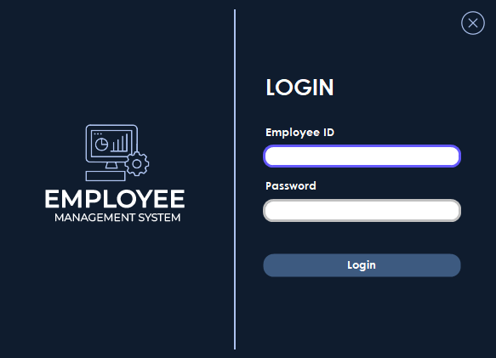

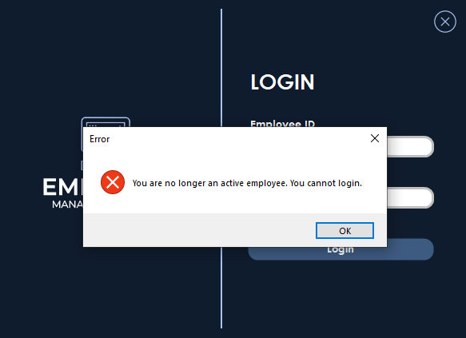

- Admin Login
Once the admin logs in, the dashboard is displayed. It shows the total number of employees, active employees, and inactive employees. Employee data includes empid, name, position, salary, manager ID, and department ID. Department information is also shown. Additionally, a pie chart displays the total available tickets for projects.
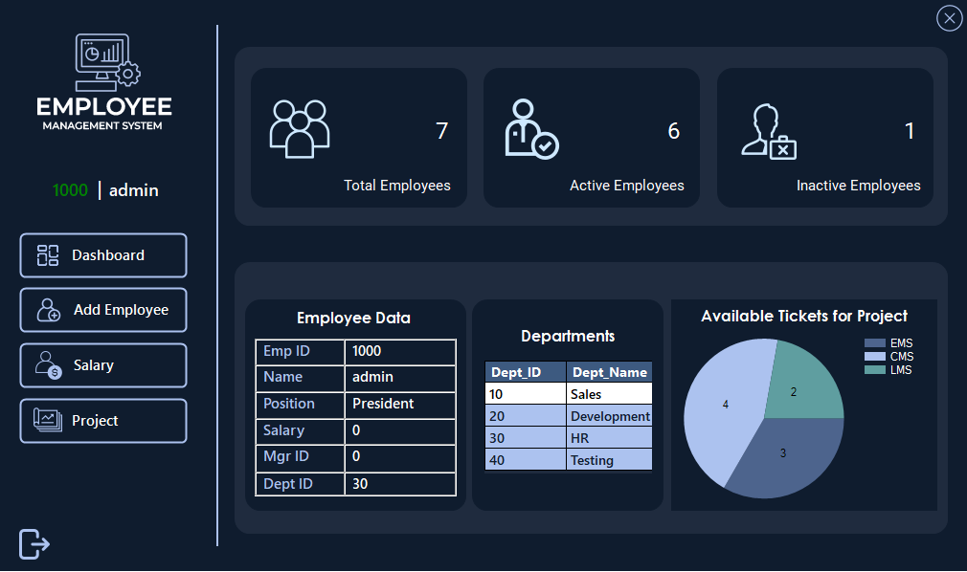

The admin can add, update, delete, and clear employee records. For a manager, the employee ID (empid) must be between 1001 and 1099 inclusive. For an employee, the employee ID (empid) must be 1100 or higher.
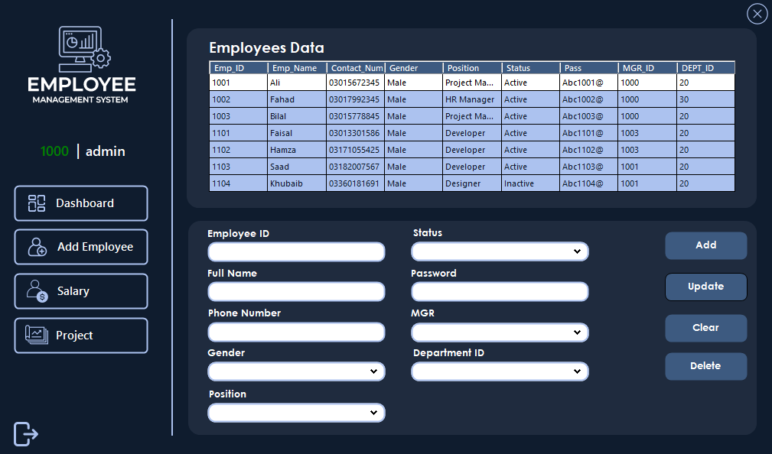

Upon clicking the salary button, the salary user control is displayed, allowing the admin to update employee salaries.
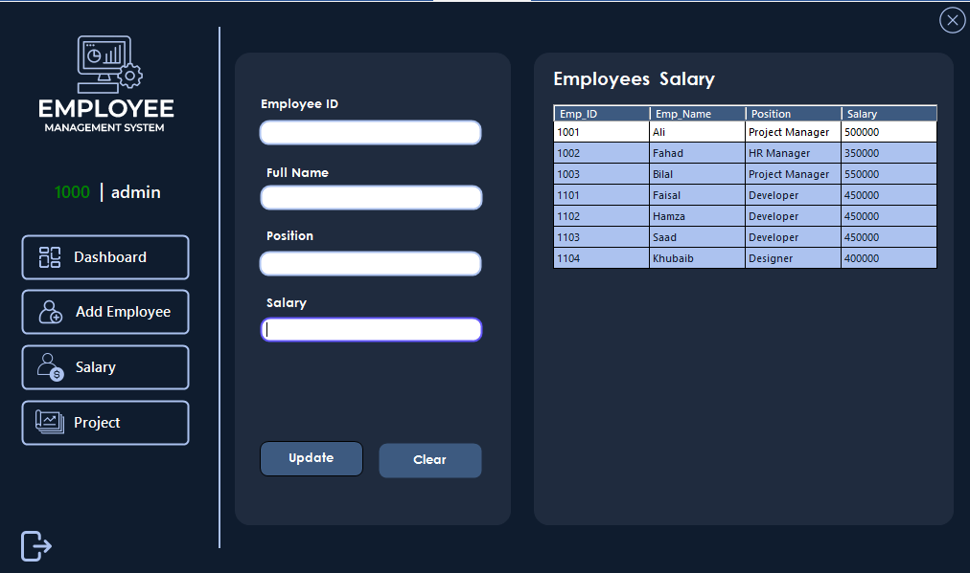

Upon clicking the project button, the admin can add, update, and delete projects. Projects can be assigned to managers by selecting a manager ID from a drop-down menu. Once added, project details, including total tickets, completed tickets, tickets in progress, and project status, are displayed in a data grid view.
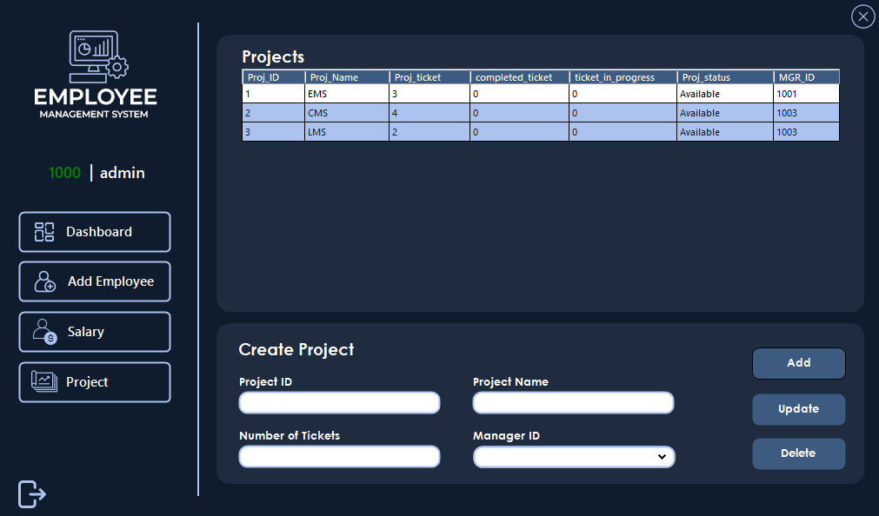

- Employee Login
When an employee logs in, they see a dashboard similar to the admin's dashboard.
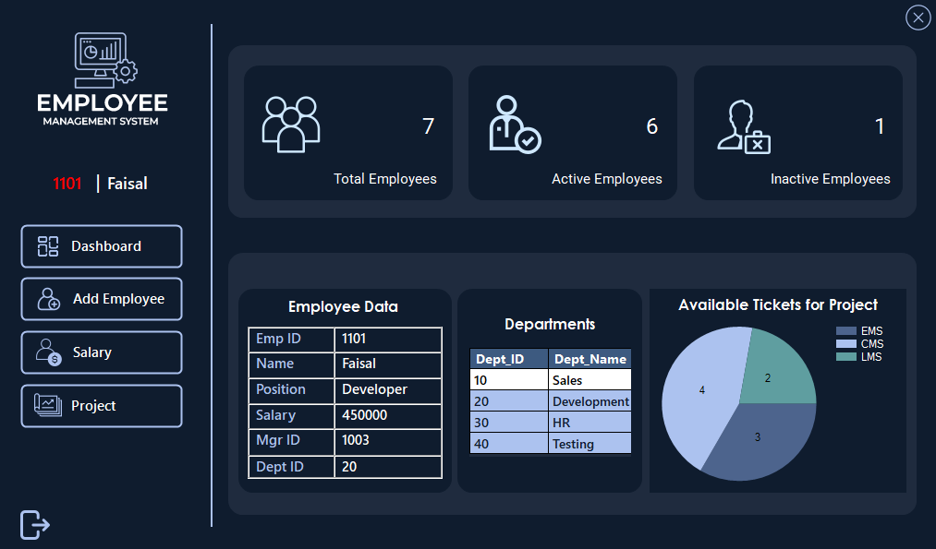

Employees do not have permissions to perform CRUD operations on employees. If they click on the "Add Employee" or "Salary" button, an error message is displayed stating "Access denied: You don't have necessary permissions to perform this action."
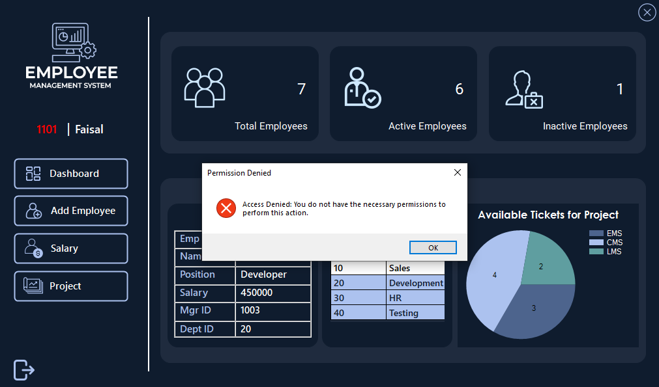

Employees can choose available project to work on. Clicking a project in the data grid view asks, "Are you sure you want to accept this project?" If confirmed with "Yes," a new ticket is generated with status "Hold," decreasing available tickets by one and increasing tickets in progress by one.
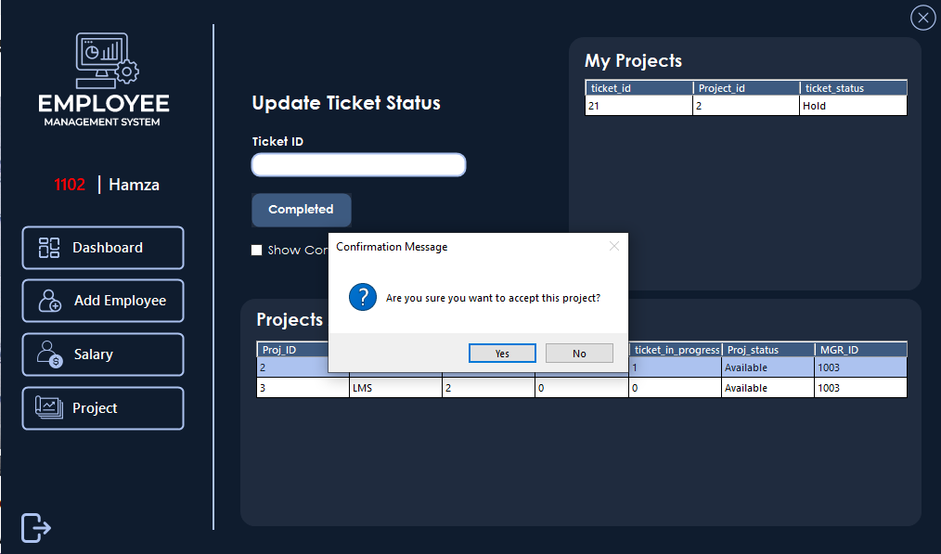

Once the project is completed, the employee can update the ticket status to "Complete." Upon doing so, the count of completed tickets increases by one, and the count of tickets in progress decreases by one.
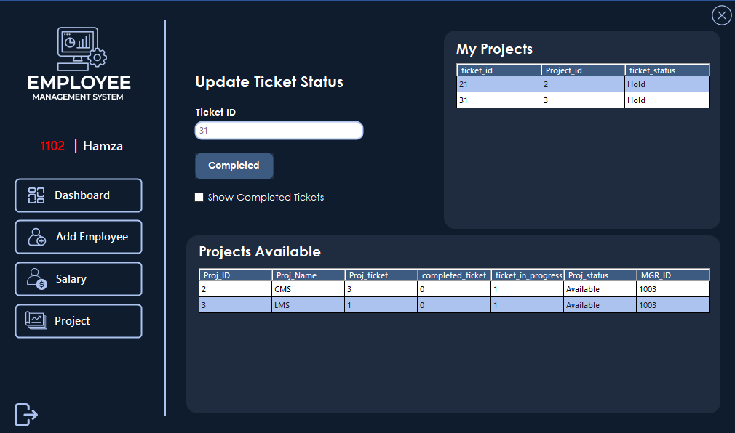

Clicking "Show Completed Tickets" displays the completed tickets in a data grid view.
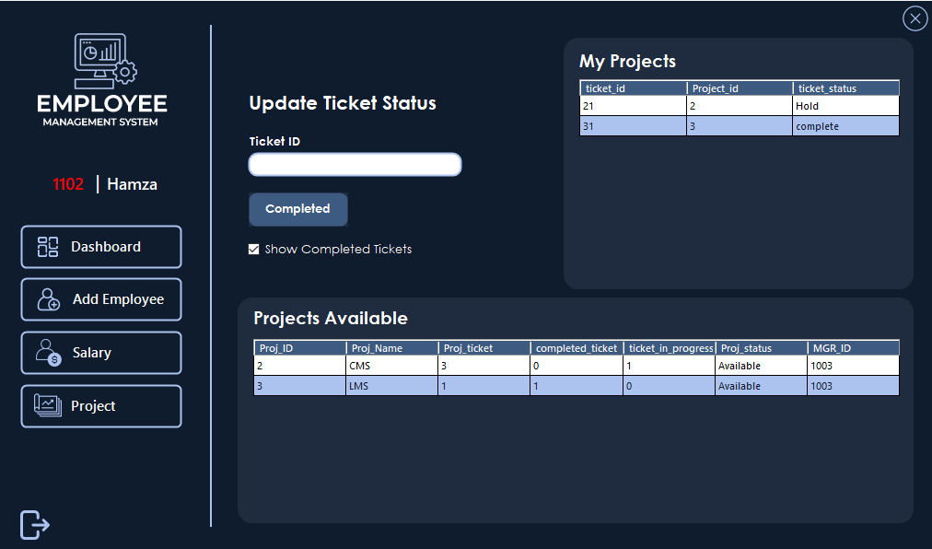

- Manager Login
When a manager logs in, they see a dashboard similar to the admin's dashboard.
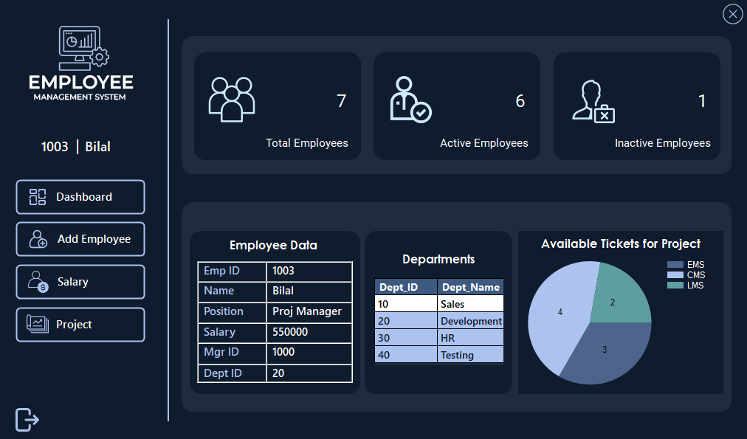

Managers do not have permissions to perform CRUD operations on employees. If they click on the "Add Employee" or "Salary" button, an error message is displayed stating "Access denied: You don't have necessary permissions to perform this action."
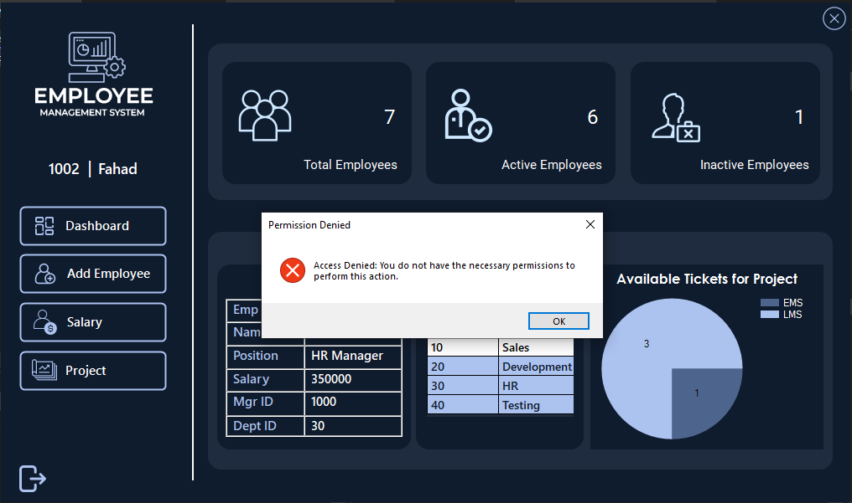

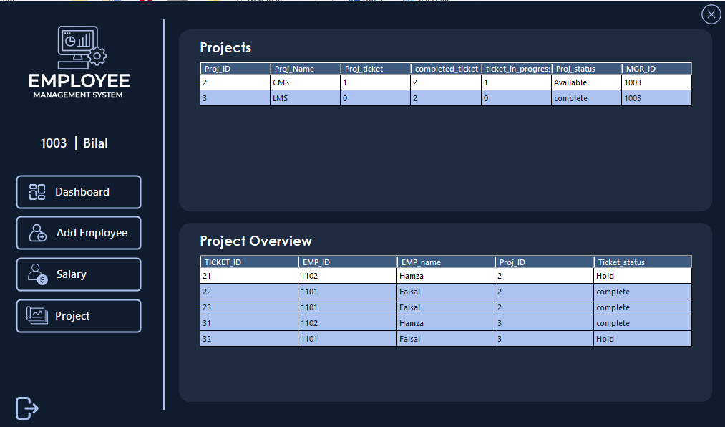
Managers manage employees through their project user control, where they can view a project overview. This overview shows which project and ticket ID each employee is working on, along with the ticket's status. Additionally, projects assigned to the manager by the admin are also displayed.

